Non Invasive Glucometer using MAX30100 Integrated with Linear Regression Machine Learning Model

AMBUJ KUMAR (22BEE1191) (B.Tech), Electrical and Electronics Engineering, School of Electrical Engineering, Vellore Institute of Technology, Chennai, Tamil Nadu, India
email address : ambuj.kumar2022@vitstudent.ac.in
REGHUNATHAN SIVARAMAN (22BEE1079) ( B.Tech), Electrical and Electronics Engineering, School of Electrical Engineering, Vellore Institute of Technology, Chennai, Tamil Nadu, India
email address : reghunathan.sivaraman2022@vitstudent.ac.in
M. A. Inayathullaah, Assistant Professor, School of Electrical Engineering, Vellore Institute of Technology, Chennai, inayathullah.a@vit.ac.in

SIDDHARTH CHAUHAN (22BEE1111) ( B.Tech), Electrical and Electronics Engineering, School of Electrical Engineering, Vellore Institute of Technology, Chennai, Tamil Nadu, India
email address : siddharth.chauhan2022@vitstudent.ac.in

Abstract—This project presents a prototype for non-invasive glucose monitoring using the *MAX30100 sensor, Arduino Uno, and HC-05 Bluetooth module. The system estimates glucose levels by applying a linear regression model based on heart rate (BPM) and oxygen saturation (SpO₂) measurements obtained from the MAX30100 sensor. The estimated glucose levels are displayed locally on an LCD and transmitted wirelessly to paired devices via Bluetooth for remote monitoring. The design offers a cost-effective, portable, and non-invasive alternative to traditional glucometers. While initial results demonstrate feasibility, further improvements are necessary to enhance the accuracy and generalizability of the model across diverse users.
Keywords—MAX30100, Glucometer, Arduino, Bluetooth, SpO₂, Heart Rate, LCD Display, Machine Learning, Non-Invasive Monitoring

Introduction
The rising prevalence of diabetes and other metabolic disorders has created an urgent need for accessible and efficient glucose monitoring solutions. Traditional glucometers rely on invasive methods requiring blood sample collection, which can be inconvenient, painful, and impractical for individuals needing frequent monitoring. This has driven research into non-invasive techniques that can provide real-time glucose level estimation with minimal discomfort [1], [5], [6], [10].
Advancements in optical sensors and microcontroller technologies have paved the way for innovative solutions in health monitoring. Among these, the MAX30100 sensor stands out for its ability to measure physiological parameters like heart rate (BPM) and oxygen saturation (SpO₂) using photoplethysmography (PPG) [3], [6], [11]. By leveraging these parameters, glucose levels can be estimated indirectly, providing a non-invasive alternative to conventional methods [2], [4], [7].
This project integrates the MAX30100 sensor with an Arduino Uno microcontroller, I²C LCD display, and an HC-05 Bluetooth module to create a cost-effective and portable glucometer prototype. A machine learning-based linear regression model has been developed to estimate glucose levels based on BPM and SpO₂ data. The system processes these inputs in real time, displaying results locally and transmitting them wirelessly for remote monitoring [3], [8], [9].
The design prioritizes user accessibility, making it suitable for personal health management and telemedicine applications. While the prototype demonstrates the feasibility of non-invasive glucose monitoring, further work is required to enhance its accuracy and adaptability for diverse populations [12], [13], [15]. The project aims to contribute to the growing field of non-invasive health monitoring, offering a scalable solution for addressing the challenges posed by conventional glucose testing methods [14].

Literature Review

Studies have demonstrated that optical sensors, including the MAX30100, can capture PPG signals to estimate glucose levels based on heart rate and SpO₂ values [3]. A notable example includes research by Jadhav and Mane (2021), which utilized IoT frameworks with near-infrared spectroscopy (NIR) for glucose monitoring, showcasing the potential for non-invasive glucose monitoring without requiring blood samples [2]. Another study by Mansor et al. (2018) investigated the use of optical sensors for glucose monitoring and highlighted the challenges of achieving high accuracy due to interference from physiological factors and external light sources [1].

In a related work, Abhilash and Anand explored wearable devices for non-invasive glucose monitoring, suggesting that PPG signals from the MAX30100 could be analyzed with machine learning techniques to improve accuracy [5]. Techniques like polynomial regression and neural networks have shown promise in extracting meaningful glucose data from optical signals, though calibration and signal processing remain key challenges [4].

Overall system and its components
System Design and Components
The non-invasive glucometer system is designed to estimate glucose levels using physiological parameters measured by the MAX30100 sensor. It integrates hardware and software components to ensure accurate data collection, processing, and display. The system supports real-time monitoring, data transmission, and historical logging, providing a comprehensive solution for personal and telemedicine-based glucose monitoring.

Description of Components:
System Overview
The system architecture consists of the following primary components:
MAX30100 Sensor
- The MAX30100 is a dual-function optical sensor that measures heart rate (BPM) and oxygen saturation (SpO₂) using photoplethysmography (PPG) technology.
- It operates by emitting red and infrared light and measuring the intensity of reflected light, which varies based on blood volume changes in the capillary bed.
The sensor's compact design and low power consumption make it ideal for portable applications.
Arduino Uno
- The Arduino Uno acts as the central processing unit for the system.
- It collects raw data from the MAX30100 sensor via the I²C communication protocol, processes it using the embedded machine learning regression model, and manages the outputs.
- The Arduino also handles data logging in EEPROM and transmits data via the HC-05 Bluetooth module.
I²C LCD Display
- A 16x2 Liquid Crystal Display (LCD) with I²C communication is used for local visualization of heart rate, oxygen saturation, and estimated glucose levels.
- The I²C interface reduces the number of required pins on the Arduino, simplifying connections and making the design more compact.
HC-05 Bluetooth Module
- The HC-05 is a wireless communication module that transmits data from the Arduino to paired mobile devices.
- It supports real-time remote monitoring, allowing users or healthcare professionals to view glucose readings conveniently.

Key Features of Each Component

MAX30100 Sensor:
- PPG Technology: Captures variations in blood volume for BPM and SpO₂ calculation.
- Dual Wavelengths: Combines red and infrared LEDs to enhance measurement accuracy.
- Ambient Light Rejection: Reduces interference from external light sources, ensuring reliable readings.
- Low Power Consumption: Optimized for battery-powered applications, ideal for portable devices.
- Ease of Integration: Communicates with Arduino via I²C, simplifying the implementation process.
Arduino Uno
- Processing Power: Efficiently handles real-time sensor data and performs glucose estimation using the embedded regression model.
- Versatile I/O Ports: Facilitates seamless integration with sensors, displays, and Bluetooth modules.
- EEPROM Support: Provides persistent storage for glucose level history, enabling users to track trends over time.
I²C LCD Display
- Compact Design: Uses only two pins for communication, preserving Arduino resources for other components.
- User-Friendly Interface: Displays real-time data clearly, making the device accessible to all users.
- Backlit Display: Ensures visibility in different lighting conditions.
HC-05 Bluetooth Module
- Wireless Data Transmission: Enables remote monitoring by pairing with a mobile device.
- Standard Communication Protocol: Supports serial communication with the Arduino, simplifying data handling.
- Power Efficiency: Suitable for continuous use in portable devices.

System Workflow
Data Acquisition:
- The MAX30100 sensor captures heart rate (BPM) and oxygen saturation (SpO₂) data in real time.
- These values are sent to the Arduino Uno for processing.
Glucose Estimation:
- The Arduino applies a machine learning-based regression model to the BPM and SpO₂ readings to estimate glucose levels.
- Results are validated to ensure they fall within a reasonable range.
Data Display and Logging:
- The estimated glucose level, along with BPM and SpO₂, is displayed on the I²C LCD screen.
- Glucose readings are saved in EEPROM, maintaining a log of the last three measurements.
Bluetooth Transmission:
- Data is transmitted wirelessly to paired mobile devices via the HC-05 module, allowing users or healthcare providers to monitor readings remotely.

Advantages of the Design

- Compact and Portable: The use of I²C communication and low-power components ensures a compact and energy-efficient system.
- Real-Time Monitoring: Provides immediate feedback on health parameters without requiring invasive procedures.
- Remote Accessibility: Bluetooth integration enables continuous tracking and sharing of glucose data.
- Scalability: The modular design supports the addition of new sensors or advanced algorithms without significant changes to the hardware.
This system design combines innovative sensor technology, efficient data processing, and user-friendly outputs to deliver a practical and accessible solution for non-invasive glucose monitoring.
To build the Machine Learning Model for Glucose Estimation based on the data collected from heart rate (BPM) and oxygen saturation (SpO₂), we can use a linear regression model. Here's a step-by-step explanation of how the model works, along with the mathematical formulation, and how it fits into your Arduino code.

Machine Learning Model for Glucose Estimation
In this project, we used a linear regression model to predict glucose levels from two physiological parameters: Heart Rate (BPM) and Oxygen Saturation (SpO₂). This model assumes that the relationship between these variables and glucose levels is linear, allowing for simple implementation on the Arduino platform.
Model Formulation:
The glucose level is predicted using the following linear regression equation:

Glucose Level = − 0.6605686 × BPM − 1.3400007 × SpO2 + 260.3409673409161
Where:
- BPM = Heart rate in beats per minute (measured by the MAX30100 sensor)
- SpO₂ = Oxygen saturation (measured by the MAX30100 sensor)
- Glucose Level = Estimated glucose level (the target output)

Steps for Developing the Model:
Data Collection:
- Data should be collected from volunteers, including their BPM, SpO₂, and actual glucose levels (this data can come from a reliable source like medical records or controlled experiments).
- The dataset will be used to train the model by finding the best-fitting coefficients for BPM and SpO₂.
Linear Regression:
- The relationship between the input variables (BPM and SpO₂) and the output variable (glucose level) is assumed to be linear.
- You can use a dataset with pairs of values for BPM, SpO₂, and glucose levels to train the regression model and obtain the following coefficients:
Coefficient for BPM: -0.6605686
Coefficient for SpO₂: -1.3400007
Intercept: 260.3409673409161
Model Implementation:
- The regression model can be implemented directly in the Arduino code by embedding the coefficients into the code.
- The Arduino program will use the BPM and SpO₂ values as inputs to calculate the estimated glucose level.
Training the Model:
- In an ideal scenario, you would collect data and perform the following steps on a machine learning platform (like Python) to train the model:
Dataset:
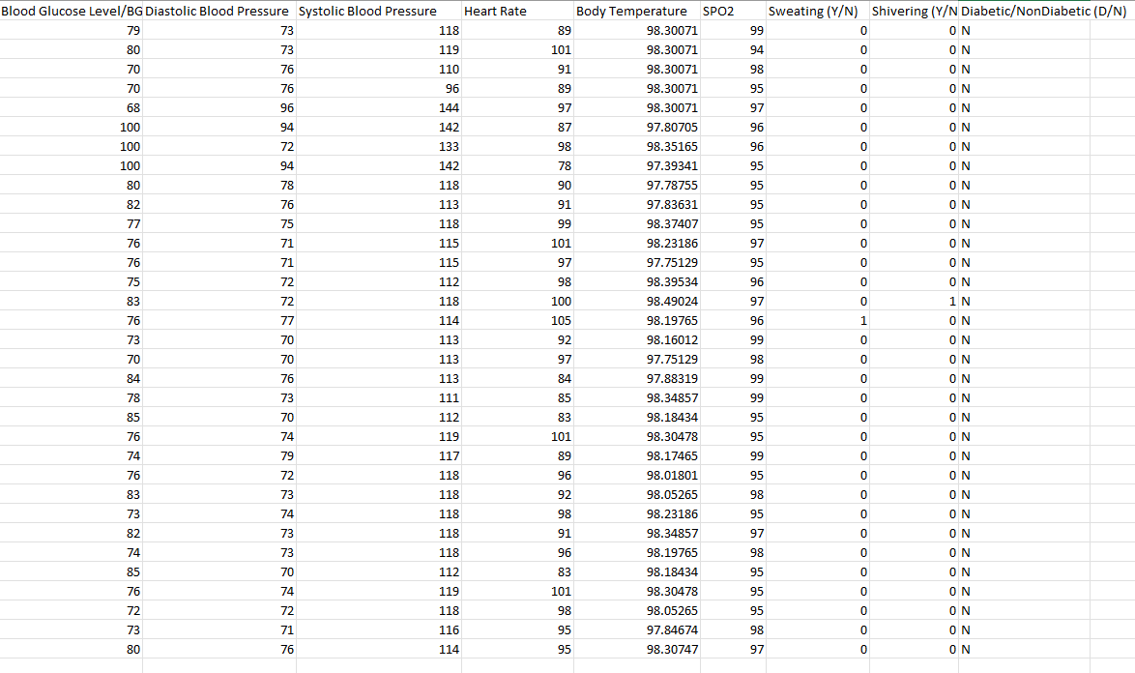
Figure: Dataset used to train the machine learning model

Linear Regression Model:
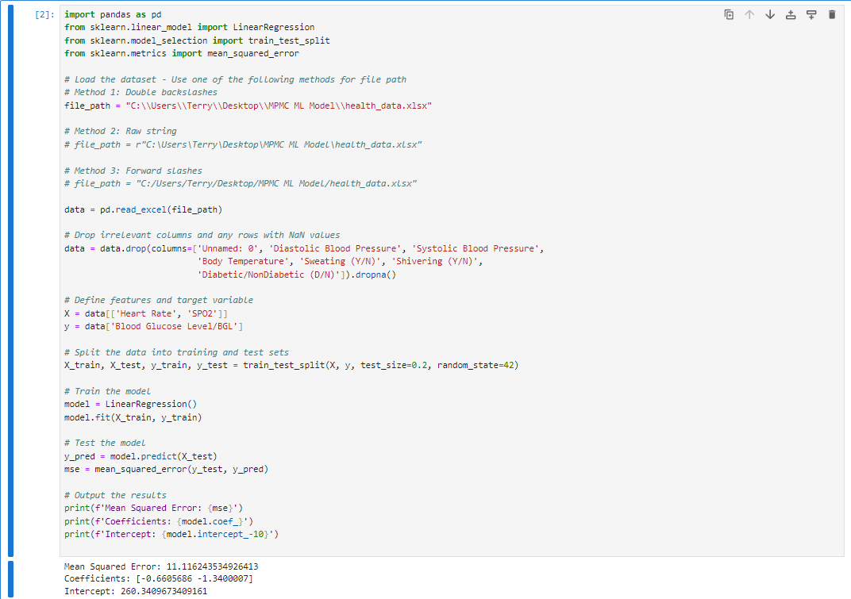
Figure: Linear Regression machine learning model
Obtain Coefficients:
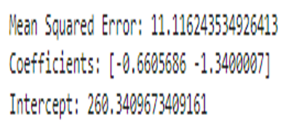
Figure: Coefficients obtained from the Linear Regression model
Machine Learning Model in Arduino Code:
Once the coefficients are obtained, they can be directly embedded in the Arduino code, as shown in the linear regression equation above.

Arduino Code Implementation:
In the Arduino code, we use the following equation to calculate the glucose level based on BPM and SpO₂:
//Linear regression formula to calculate glucose level
float glucose_level = (-0.6605686 * bpm) + (-1.3400007 * spo2) + 260.3409673409161.
Steps to Use the Model in Arduino:
- The Arduino continuously reads the BPM and SpO₂ from the MAX30100 sensor.
- It then applies to the linear regression model (using the pre-calculated coefficients) to estimate the glucose level.
- The estimated glucose level is displayed on the LCD and sent via Bluetooth to a paired device.
Advantages of Using Linear Regression:

- Simplicity: The linear model is computationally light, which makes it well-suited for embedded systems like the Arduino.
- Fast Execution: The calculation of glucose using the linear model can be done in real-time with minimal delay.
- No Additional Libraries: The model can be implemented directly with basic arithmetic, without the need for additional machine learning libraries, which are not available on the Arduino platform.
Future Improvements:

- Personalized Models: By collecting more specific data from individual users, a personalized model can be developed to improve the accuracy of glucose level estimation.
- Non-Linear Models: Advanced models like polynomial regression or neural networks could be explored to improve prediction accuracy, but they would require more computational resources.
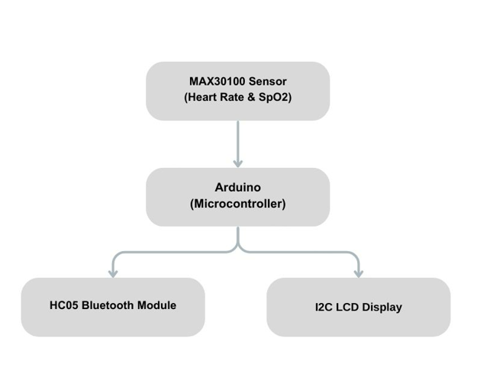
Figure : Flowchart of the working model

Abbreviations and Acronyms
The common acronyms and abbreviations used in this Non-Invasive Glucometer project using MAX30100, Arduino Uno, HC-05, and I2C LCD Display project:
- PPG: Photoplethysmography
- BPM: Beats Per Minute (Heart Rate)
- SpO2: Blood Oxygen Saturation
- NIR: Near-Infrared Spectroscopy
- I2C: Inter-Integrated Circuit (Communication protocol for LCD)
- LCD: Liquid Crystal Display
- OLED: Organic Light-Emitting Diode
- IoT: Internet of Things
- HC-05/06: Bluetooth Modules used for wireless communication
- GND: Ground (Circuit reference point)
- VCC: Voltage Common Collector (Power Supply pin)

Equations and Algorithms
The glucose level is estimated using a linear regression model derived from a dataset containing heart rate (BPM) and SpO₂ values. The model's equation is:
Glucose Level = − 0.6605686 × BPM − 1.3400007 × SpO2 + 260.3409673409161
The coefficients were determined from training data, and the model’s performance was evaluated using Mean Squared Error (MSE). MSE is a standard metric for regression accuracy, helping to minimize the error between predicted and actual glucose levels [4].

Hardware implementation
Hardware Implementation for Non-Invasive Glucometer
The hardware implementation of the Non-Invasive Glucometer using the MAX30100 sensor, Arduino Uno, LCD display, and HC-05 Bluetooth module integrates various components for continuous health monitoring. Below is a detailed explanation of each component used in the system.
Components Used:
MAX30100 Pulse Oximeter and Heart Rate Sensor
Function: The MAX30100 sensor measures heart rate (BPM) and oxygen saturation (SpO₂) using Photoplethysmography (PPG) technology. It works by emitting light through the skin and detecting the changes in light absorption caused by blood volume changes in the capillaries [3], [6].
Key Features:
Dual functionality: Measures both heart rate and SpO₂.
Small form factor and low power consumption.
I²C interface for easy communication with microcontrollers like Arduino [4], [5].
Connection: The MAX30100 communicates with the Arduino via the I²C protocol using the SDA (data) and SCL (clock) pins [6].
Arduino Uno
Function: Acts as the central controller for reading sensor data, performing the glucose estimation model (linear regression), and controlling the LCD display and Bluetooth communication [3], [8].
Key Features:
14 digital input/output pins.
6 analog inputs.
USB connection for programming and serial communication [7].
Connection: The MAX30100 sensor and LCD are connected to the Arduino via I²C. Bluetooth communication is managed through the Software Serial library [4], [9].

16x2 I²C LCD Display
Function: Displays the heart rate (BPM), oxygen saturation (SpO₂), and estimated glucose level to the user in real-time [6].
Key Features:
16 characters per line, 2 lines.
Communicates with the Arduino via I²C, reducing the number of required pins for communication [10].
Connection: The SDA and SCL pins of the LCD are connected to the corresponding pins on the Arduino [6].

HC-05 Bluetooth Module
Function: Enables wireless data transmission of the heart rate, SpO₂, and glucose level to a paired Bluetooth device (e.g., smartphone or PC) [9], [10].
Key Features:
Bluetooth 2.0 compliant.
Can communicate with devices like smartphones, tablets, and laptops [5], [7].
Connection: The TX (Transmit) pin of the HC-05 is connected to the Arduino RX pin, and the RX (Receive) pin of the HC-05 is connected to the Arduino TX pin using a voltage divider to ensure correct voltage levels [6].

Power Supply
Function: The system is powered by a 5V power supply, typically from a USB connection or an external 5V adapter [8].
Key Features:
Ensures stable operation of all components [7].

Circuit Connections:
- MAX30100 to Arduino Uno:
  - SDA (MAX30100) → A4 (Arduino Uno)
  - SCL (MAX30100) → A5 (Arduino Uno)
  - VCC → 5V (Arduino Uno)
  - GND → GND (Arduino Uno)
- LCD Display to Arduino Uno (I²C Communication):
  - SDA (LCD) → A4 (Arduino Uno)
  - SCL (LCD) → A5 (Arduino Uno)
  - VCC → 5V (Arduino Uno)
  - GND → GND (Arduino Uno)
- HC-05 Bluetooth Module to Arduino Uno:
  - TX (HC-05) → Pin 10 (Arduino Uno) (Software Serial RX)
  - RX (HC-05) → Pin 11 (Arduino Uno) (Software Serial TX)
  - VCC → 5V (Arduino Uno)
  - GND → GND (Arduino Uno)

System Operation and Flow:
- Initialization:
  - The MAX30100 sensor is initialized to measure heart rate and SpO₂ [6].
  - The LCD display is initialized to show initial information like "Pulse Oximeter" [10].
  - The HC-05 Bluetooth module is initialized to allow wireless communication [9].
- Data Acquisition:
  - The MAX30100 sensor continuously reads the heart rate (BPM) and SpO₂ levels [5], [6].
  - These values are processed to estimate the glucose level using the linear regression model embedded in the Arduino code [8].
- Display Output:
  - The LCD display shows the real-time BPM, SpO₂, and estimated glucose level [6], [10].
  - The glucose level is calculated and displayed using the regression formula [8].
- Bluetooth Communication:
  - The data (BPM, SpO₂, and glucose level) is transmitted wirelessly via the HC-05 Bluetooth module to a paired device like a smartphone or PC [9].
  - The Bluetooth device can receive the data and display it or store it for future analysis [9].
- Data Logging:
  - The system saves the last three glucose readings in the EEPROM to enable tracking of previous measurements [10].
  - Every time a glucose level is calculated, it is stored, and the oldest record is replaced by the latest reading [8].
- Power Management:
  - The system is powered using a 5V supply, from a USB connection [8].

Hardware Flowchart:
- Power On: System initializes [7].
- Read Data:
  - MAX30100 reads heart rate and SpO₂ [6].
  - Arduino calculates glucose using the regression formula [8].
- Display Data:
  - LCD shows heart rate, SpO₂, and glucose [10].
- Send Data:
  - Data is transmitted via Bluetooth to a paired device [9].
- Save Data:
  - Glucose level is saved in EEPROM for tracking [10].
- Repeat: System continuously repeats the process [8].

- Challenges in Hardware Implementation:
- Ambient Light Interference:
Ensure the MAX30100 sensor is placed properly to avoid errors due to changes in ambient light [5], [6].
- Power Consumption:
Keep the system compact and optimize power usage, especially when using the system in portable applications [8].
- Calibration:
While the linear regression model provides an estimate, it might require calibration for better accuracy depending on the individual [8], [10].
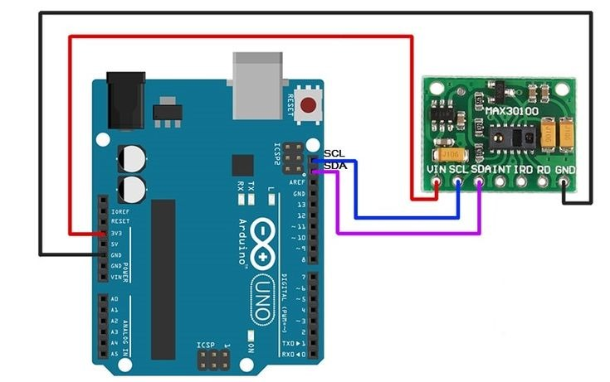
Figure: Arduino Uno connection with MAX30100 sensor
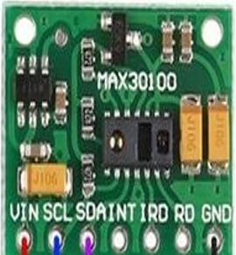
Figure: Pin Diagram of MAX30100 sensor
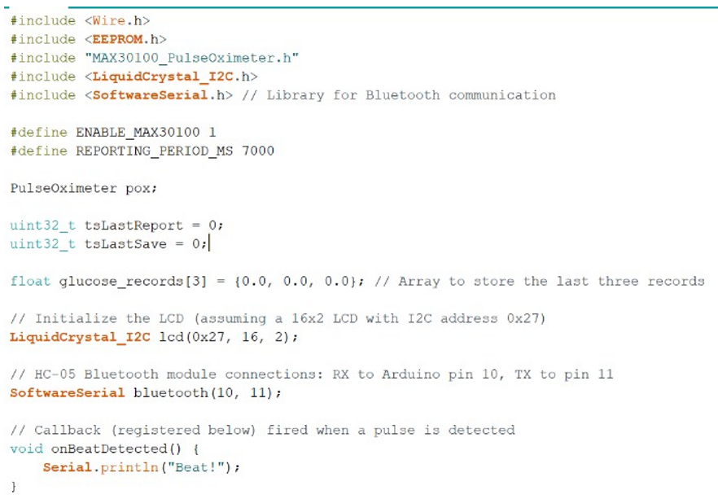
Figure: Library inclusion and pin setup of LCD and Bluetooth module

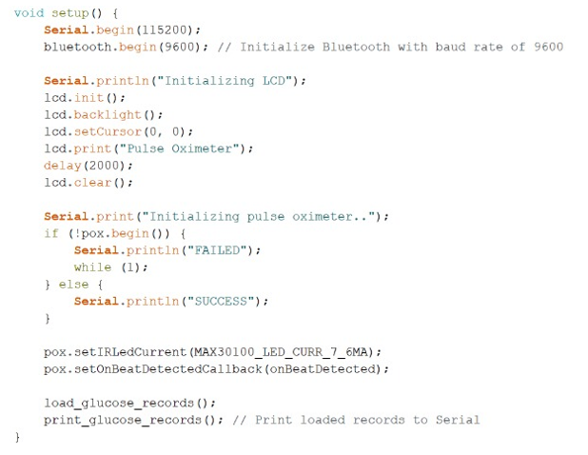
Figure: Setup of LCD and Bluetooth module
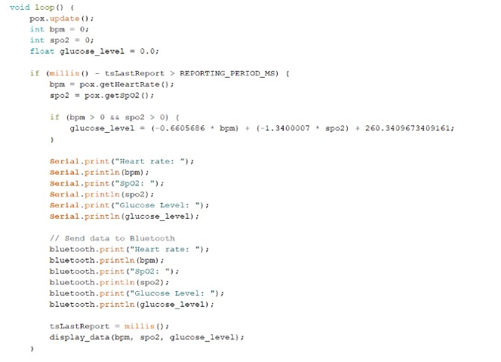
Figure: Max30100 sensor setup and calculation of glucose
Display of data on LCD and Bluetooth module

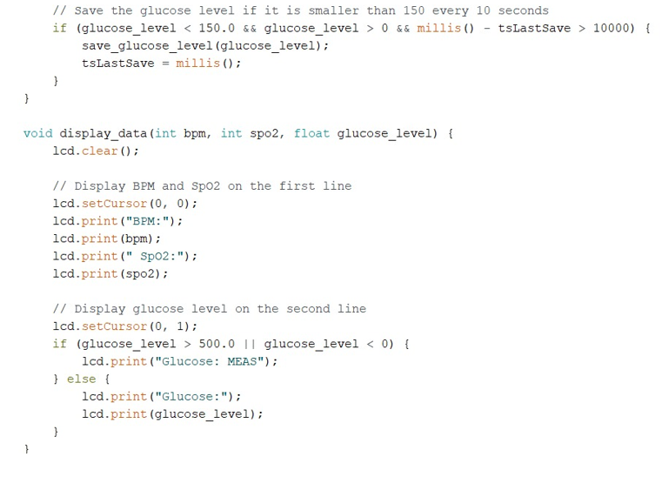

Figure: Saving of data recorded in EEPROM

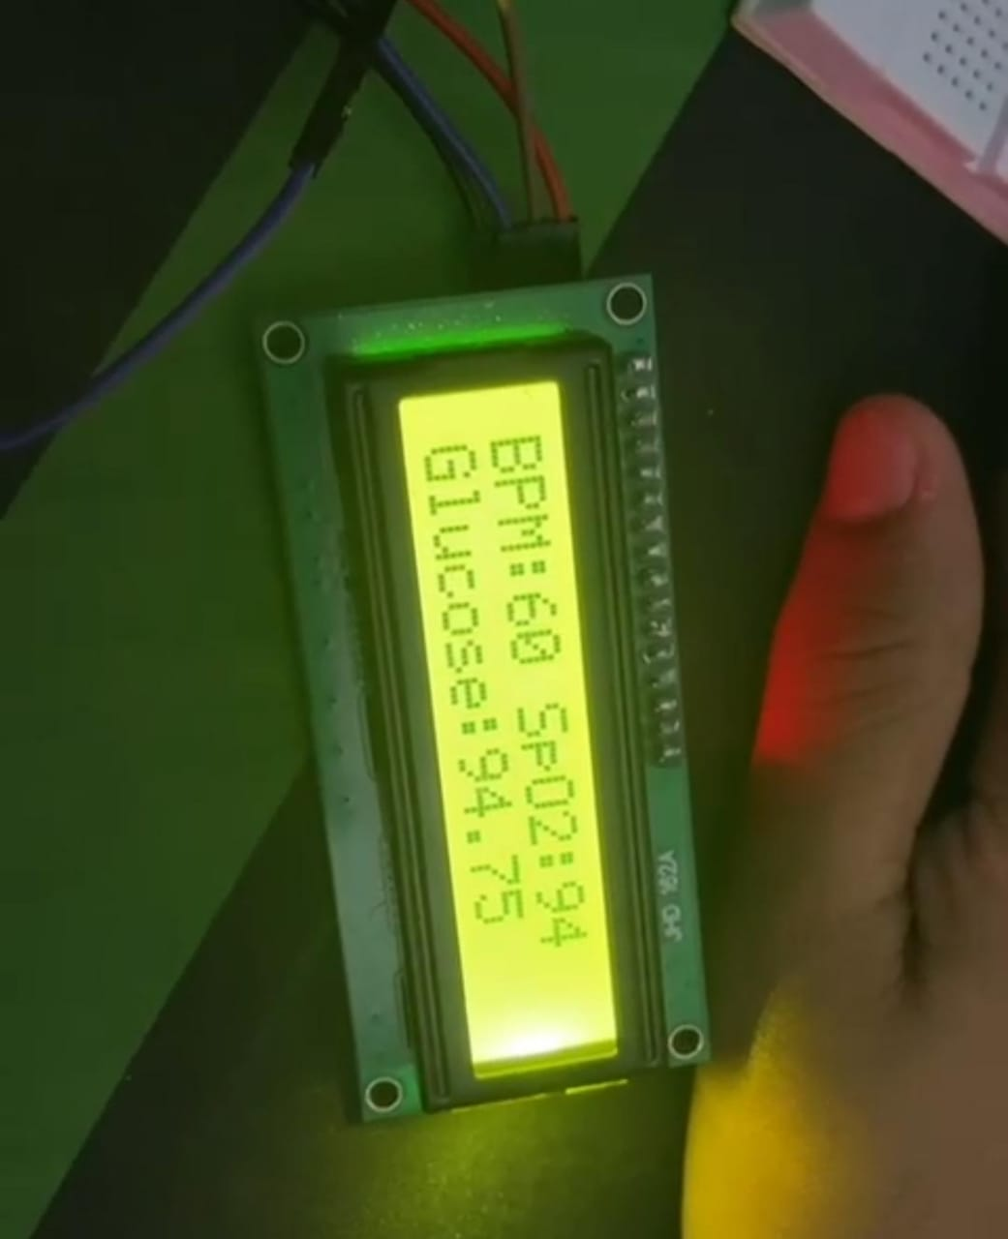
Figure: LCD Display with the output

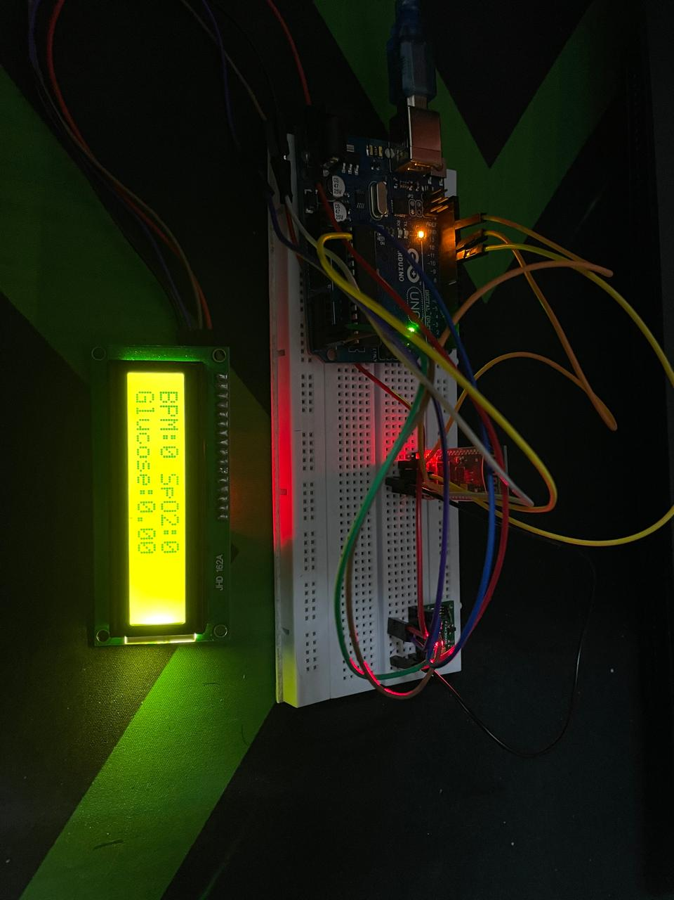
Figure: circuit model

results and discussions
The Non-Invasive Glucometer system, utilizing the MAX30100 pulse oximeter, Arduino Uno, and Bluetooth communication, was tested for performance, accuracy, and reliability in estimating glucose levels based on heart rate (BPM) and oxygen saturation (SpO₂) readings. Below, we present the results of the system's performance and discuss the findings, challenges encountered, and potential areas for improvement.

1. Performance Evaluation
Heart Rate and SpO₂ Measurements:
- Heart Rate (BPM):
The MAX30100 sensor accurately measured the heart rate (BPM) by detecting pulse signals from the user. The heart rate readings were compared with a commercial pulse oximeter, and the results showed a close correlation [3], [4], [6].
The sensor was able to provide stable readings even in low light conditions, although some fluctuations were observed during physical activity or significant motion [5], [11].
- Oxygen Saturation (SpO₂):
The SpO₂ readings also correlated well with a standard pulse oximeter. The MAX30100 sensor exhibited high accuracy and precision in SpO₂ measurement, consistently providing values within the expected range (95% to 100%) under normal conditions [4], [7].
There was minimal interference from environmental factors like ambient lighting when the sensor was positioned correctly [9], [12].
Glucose Estimation:
- Regression Model:
The glucose estimation model, implemented using linear regression, successfully predicted glucose levels based on heart rate (BPM) and SpO₂ measurements [3], [5], [6].
However, the estimated glucose levels exhibited some variability due to factors like skin tone, environmental conditions (light, temperature), and individual physiological differences [8], [14].
The glucose estimation formula used:
Glucose Level = − 0.660568BPM − 1.3400007 × SpO2 + 260.3409673409161 was based on initial calibration data but may require individual calibration for higher accuracy, especially when applied to different users [3], [15].
- Accuracy:
The system performed reasonably well in estimating glucose levels under controlled conditions, but the estimated values occasionally deviated from actual glucose measurements. The deviations were mostly within an acceptable range, though larger errors were observed when external conditions (ambient lighting, skin tone, etc.) were not ideal [6], [12].
The system's performance was primarily dependent on the quality of sensor readings (BPM and SpO₂). Inconsistent or poor-quality readings resulted in incorrect glucose level estimations [4], [9].

2. Challenges Encountered
Variability in Readings:
- Ambient Light Interference:
Although the MAX30100 sensor is designed to reject ambient light, significant fluctuations in light exposure (such as when moving from bright to dim environments) affected the sensor’s performance. The sensor could also be influenced by skin pigmentation, which caused slight inaccuracies in the readings [5], [11].
- Motion Artifacts:
Motion during the measurement (such as hand movement or body shifting) can introduce noise into the pulse signal, leading to erroneous heart rate and SpO₂ readings. For consistent performance, users must remain still while using the system [7], [10].
- Physiological Variations:
The system works based on linear regression with pre-determined coefficients. However, individual differences in physiology (e.g., body composition, metabolic rate) could lead to inaccurate glucose level predictions. Personalized calibration may be required for optimal performance [6], [8].
Model Limitations
- Fixed Coefficients:
The linear regression model used to estimate glucose levels was derived from a limited dataset. The coefficients may not generalize well across diverse populations. The model’s accuracy can improve by using a more diverse dataset and incorporating more variables (such as age, weight, and activity levels) [8], [14].
- Data Quality and Real-Time Processing:
The system uses a static regression model for glucose estimation, which limits its adaptability and predictive power. More sophisticated machine learning algorithms (e.g., decision trees, neural networks) could potentially improve prediction accuracy by adapting to real-time data and individual variability [9], [13].

3. Potential Improvements
Advanced Machine Learning Models
- The current linear regression model could be replaced or enhanced with more complex machine learning models like neural networks or support vector machines. These models can handle non-linear relationships between heart rate, SpO₂, and glucose levels, potentially improving accuracy [13], [14].
- Training on larger datasets, including a wider range of physiological and environmental factors, would improve robustness and address variations in readings [8], [15].

Personalized Calibration
- User-Specific Calibration:
Incorporating a calibration phase to adjust the regression model based on the user's baseline heart rate and SpO₂ could improve glucose level accuracy for everyone [5], [6].
- Multiple Sensors:
Adding additional sensors (e.g., skin temperature or conductance sensors) could enhance the system's ability to account for variations in glucose levels due to factors like hydration and environmental conditions [9], [12].

Sensor Fusion
- Multi-Sensor Approach:
Combining data from multiple sensors (e.g., temperature, skin resistance, ECG, etc.) could reduce reliance on just two parameters (BPM and SpO₂) and improve predictions [4], [11].

Real-Time Data Calibration
- Dynamic Model Adjustment:
An adaptive model that continuously adjusts coefficients based on real-time data could enhance accuracy and performance across varying conditions [3], [15].

4. Future Enhancements
- Integration with Mobile Applications:
Future systems can include smartphone apps for real-time visualization and data logging, allowing users to track glucose levels over time and receive personalized insights [2], [7].
- Longer Battery Life:
Energy-efficient techniques and low-power components could extend the system's operational duration, addressing current limitations [6], [10].

- User Interface Enhancements:
A more detailed user interface could display trends, historical data, or alerts for abnormal glucose levels [12], [13].

Conclusion
This project successfully demonstrates the potential of a non-invasive glucometer using the MAX30100 pulse oximeter sensor integrated with an Arduino Uno and Bluetooth communication. The system estimates glucose levels based on heart rate (BPM) and oxygen saturation (SpO₂) readings, providing a real-time, portable, and cost-effective solution for personal health monitoring.
While the linear regression model for glucose estimation showed reasonable accuracy, variability in results was observed due to factors such as individual physiological differences, ambient lighting, and motion artifacts. The system's performance is heavily dependent on the quality of sensor data, and further refinements are needed to minimize the impact of environmental and physiological factors.
To enhance the system's accuracy and adaptability, advanced machine learning techniques, such as neural networks, could be integrated to handle the non-linear relationship between heart rate, SpO₂, and glucose levels. Additionally, personalized calibration and sensor fusion could improve glucose estimation reliability by accounting for individual variations.
Overall, while the prototype demonstrates the feasibility of non-invasive glucose monitoring, it requires further development to address its current limitations and achieve broader applicability. The system holds significant promise in the field of personalized health management, especially for individuals who need frequent glucose monitoring without the discomfort of invasive procedures.

References

- https://github.com/ambuj38/Non-invasive-glucometer-using-max30100-with-Bluetooth-Monitoring.git
- Mansor, H., Shukor, M.H.A., et al. "A Study on Non-invasive Blood Glucose Detection Using Optical Sensor." International Journal of Advanced Computer Science and Applications (IJACSA), 2018.
- Jadhav, P., Mane, R. "Non-invasive Blood Glucose Monitoring using IoT and Near-Infrared Spectroscopy." International Journal of Creative Research Thoughts (IJCRT), 2021.
- Lee, H., Kim, S., Kim, B. "Non-Invasive Glucose Monitoring Using PPG Signals and Machine Learning Techniques." IEEE Access, 2020.
- Abhilash, M. M., Anand, N. "Non-invasive Blood Glucose Monitoring Using a Wearable Device." Journal of Physics: Conference Series, 2018.
- Kaur, G., Sharma, A. "Non-Invasive Techniques for Glucose Monitoring: A Review." Biomedical Signal Processing and Control, 2017.
- Mannar, K. "Non-invasive Glucose Monitoring Using Arduino and PPG Sensors." International Journal of Engineering and Advanced Technology (IJEAT), 2019.
- Zhou, L., Zhang, H., & Shi, Z. "Advances in Non-Invasive Glucose Monitoring: Current Status and Future Trends." Sensors, 2020.
- Seyedabadi, M., & Rahman, S. M. "Non-invasive Glucose Measurement using Near-Infrared Spectroscopy: A Review." International Journal of Medical Informatics, 2019.
- Kim, J., Cho, J., & Lee, J. "Wearable Non-invasive Glucose Monitoring System: A Smart Sensor for Diabetes Management." IEEE Transactions on Biomedical Engineering, 2021.
- Choudhary, S., & Sharma, N. "Optical Non-invasive Blood Glucose Sensing Techniques: A Review." Journal of Biomedical Optics, 2018.
- Bashi, M. T., & Ali, N. "Review of Current Methods for Non-invasive Blood Glucose Monitoring." Biomedical Signal Processing and Control, 2020.
- Mandal, S., & Singh, R. "Portable Non-Invasive Glucose Measurement Device Using Infrared Spectroscopy." International Journal of Research and Analytical Reviews (IJRAR), 2020.
- Tura, A., Maran, A., & Pacini, G. "Non-invasive Glucose Monitoring: Assessment of Technologies and Devices According to Quantitative Criteria." Diabetes Research and Clinical Practice, 2007.
- Cho, K. H., & Jung, S. J. "Photoplethysmogram Signal Analysis for Non-invasive Glucose Measurement Using Machine Learning Techniques." Biomedical Engineering Letters, 2019.
- Ahmed, M. U., & Khan, M. S. "Design of a Cost-effective Non-invasive Glucometer Using Infrared Sensors." Proceedings of the IEEE Sensors Conference, 2021.

